Your AI Onboarding Map
A Simple, Friendly Guide for Everyday Users
No tech experience needed • Takes about 5 minutes • Your data stays private
👋 Welcome! This guide will walk you through using the AI Onboarding Map — a simple tool that helps you discover which AI tools could save you time and make your day easier. You do not need to be good with technology to use it. If you can send a text message, you can do this!

What's Inside This Guide
1. What Is the AI Onboarding Map?
2. How to Open and Use It
3. Understanding Each Question
4. Reading Your Personal Playbook
5. Your Privacy and Safety
6. What to Do After Getting Your Results
7. Common Questions

1. What Is the AI Onboarding Map?
The AI Onboarding Map is a short, friendly questionnaire — a bit like a quiz — that learns about your daily life and then suggests specific AI tools that could help you. Think of it as having a knowledgeable friend who listens to your problems and says, "Oh! I know exactly the right tool for that."
What it is NOT:
- It is not a test — there are no right or wrong answers
- It is not complicated — plain, everyday language throughout
- It does not collect your personal information or share it anywhere
- It does not require you to sign up or create an account
What you get at the end:
A personalised "playbook" — a short, easy-to-read summary that tells you which AI tools are best for your life, why they suit you, and exactly how to get started with each one. No confusing instructions. Just simple, clear next steps.

2. How to Open and Use It
Follow these simple steps to get started. Take your time — there is no rush!

Step 1: Open the Tool
Open ai-onboarding-map.html or use the public link you were given if the tool is hosted online.
- Open your internet browser (the app you use to visit websites — it might be Chrome, Safari, Edge, or Firefox)
- Type or paste the link you were given into the address bar at the top of the screen
- Press Enter on your keyboard (or tap Go on your phone)
- The page will load and you will see a dark screen with a teal/green logo at the top — you are in the right place!

Step 2: Fill In the Form
You will see several questions on the screen. Work through them from top to bottom. You can:
- Type your answers into the text boxes (the white/dark boxes where you can write)
- Click on cards to select your preference (they will light up in green when selected)
- Use the Voice button to speak your answer instead of typing (optional)
💡 Tip: You do not have to answer every single question perfectly. Just do your best — even a few words is enough. The more you share, the better your results will be, but there is no pressure!

Step 3: Generate Your Playbook
Gemini API key note: the key is completely optional. If you leave it blank, the tool will still generate a standard starter playbook using the exact time-drain and hobby answers you typed into the form.
- Once you have answered the questions, scroll down to the bottom of the form
- Look for the big green button that says "✨ Generate My Playbook"
- Click it once and wait a few seconds
- Your personalised playbook will appear below the button — scroll down to read it!

3. Understanding Each Question
Here is a plain-English explanation of every question in the form, so you know exactly what is being asked and why.

📱 "What apps do you use daily?"
What it means: Which apps or programmes do you already use on your phone or computer every day?
Why we ask: So we can suggest AI tools that work alongside what you already use — no need to start from scratch.
Examples you could type: Gmail, WhatsApp, Facebook, Alexa, Google Maps, Netflix, Amazon, Outlook, Zoom
How to use it: Type an app name in the box and click the green "Add" button. Each app will appear as a little tag. You can remove any by clicking the × next to it.

🧠 "How comfortable are you with technology?"
What it means: How do you prefer to interact with technology — by speaking, typing, or just trying things out?
Why we ask: Different AI tools suit different people. Someone who loves speaking will get different suggestions than someone who prefers reading.
The four options explained:
Option | What it means for you
🎙️ Voice-first | You prefer to speak rather than type. You might already use Siri, Alexa, or voice messages on WhatsApp.
⌨️ Text-comfortable | You are happy typing messages and reading on screen. You use email or messaging apps regularly.
🖐️ Hands-on | You learn best by just trying things. You do not mind clicking around to figure something out.
🔀 Mix | You use whatever is easiest at the time — sometimes you speak, sometimes you type. No strong preference.
How to use it: Click on the card that sounds most like you. It will light up in green to show it is selected.

⏳ "What takes up most of your time and drains your energy?"
What it means: What tasks in your day feel like a chore? What do you wish you could spend less time on?
Why we ask: This is the most important question! It helps us find AI tools that tackle your specific pain points.
Examples: "Answering emails takes forever", "Organising the kids' schedules", "Cooking and meal planning", "Keeping on top of bills and admin", "Remembering appointments"
How to use it: Just write in your own words — a sentence or two is perfect. Do not worry about spelling or grammar.

🌟 "What hobby or activity do you wish you had time for?"
What it means: If you had a few extra hours each week, what would you love to do?
Why we ask: This reminds us — and you — what you are working towards. Getting your time back is not just about being efficient; it is about enjoying your life more.
Examples: "Reading", "Gardening", "Going to the gym", "Painting", "Spending more time with family", "Learning to cook new recipes"

✨ "Your ideal outcome (be greedy!)"
What it means: Describe your perfect week if technology handled all the boring, repetitive stuff for you. Dream big!
Why we ask: The more specific you are, the more tailored your recommendations will be.
Example: "I want to spend less time on emails, have Saturday afternoons free for painting, and stop feeling overwhelmed by my to-do list."
🎙️ Voice tip: See the small "Voice" button in the corner of this box? You can tap it and speak your answer out loud instead of typing. Just talk naturally — it will write your words for you!

📚 "How do you like to learn new things?"
What it means: When you try a new app or gadget, how do you prefer to get started?
- "Just try it" — You like to dive straight in and figure it out as you go
- "Quick walkthrough" — A short 5-minute explanation is helpful before you start
- "Understand first" — You like to know how something works before you try it
Why we ask: This shapes how we explain each tool to you in your playbook — more detail or less, depending on your preference.

😬 "What worries you most about using AI tools?"
What it means: Is there anything that makes you nervous or hesitant about trying AI tools?
Why we ask: So we can address your specific concern in your playbook and only recommend tools that feel safe and comfortable for you.
The options: Privacy & data, Too complicated, Cost, or No worries at all — all are completely valid answers!

4. Reading Your Personal Playbook
After you click "Generate My Playbook", a personalised report will appear on the screen. Here is what each part means:

🎯 Your AI Profile
A short paragraph that sums up who you are and what you need. It is based entirely on your answers. Read it and see if it sounds like you — it usually does!

🛠️ Your Top 3 AI Tools
Three specific tools recommended just for you. For each one, you will see:
- The name of the tool
- What it does in plain English
- Why it is a good fit for you specifically
- One simple first step to get started (usually takes less than 5 minutes)
All recommended tools are free or have a free version — no credit card needed to get started.

📅 Your First Week Plan
A gentle, day-by-day plan for your first week. Day 1, Day 3, and Day 7 — each with one small, manageable action. You do not have to follow it exactly; it is just a helpful starting point.

💡 Quick Win
One thing you can do right now — in the next 10 minutes — to feel the difference AI can make. This is the best place to start if you are not sure where to begin.

🔒 Privacy Note
A short reassurance that directly addresses whatever concern you selected in the form. If you chose "Privacy & data", this section will explain exactly how your information is protected.

5. Your Privacy and Safety
We understand that privacy is important. Here is exactly what happens with your information:
- Your answers stay on your device — they are never sent to any server or stored online
- No one can see what you type — not even the people who made this tool
- There are no adverts, no tracking, and no data selling
- If you close the page, your answers disappear — nothing is saved without your permission
- You do not need to enter your name, email address, or any personal details
🔒 Bottom line: This tool is designed to help you, not to collect information about you. You are always in control. If something ever feels uncomfortable, simply close the page.

6. What to Do After Getting Your Results
You have your playbook — brilliant! Here is what to do next:

Save or Print Your Playbook
- Scroll down to find the "Download" button (it looks like a downward arrow)
- Click it to save your playbook as a text file on your device
- Or simply take a screenshot of the screen to keep a copy

Start With Your Quick Win
Find the "💡 Quick Win" section in your playbook and do that one thing today. It is designed to take less than 10 minutes and will show you immediately how helpful AI can be. Starting small is the secret to building confidence!

Try One Tool at a Time
Do not try to use all three recommended tools at once. Pick the one that excites you most and spend a week getting comfortable with it. Then move on to the next. Slow and steady wins the race!
- Week 1: Try your first recommended tool
- Week 2–3: Use it daily for one specific task
- Week 4: Explore your second recommended tool
- Month 2: You are already saving time — celebrate that!

Come Back and Try Again
Your life changes, and so do your needs. You can come back to the AI Onboarding Map any time and fill it in again. Your new answers will generate a fresh, updated playbook. Many people find their recommendations change as they get more comfortable with technology.

7. Common Questions

"Do I need to create an account or sign up?"
No. You do not need to sign up, create an account, or give your email address. Just open the link and start filling in the form.

"What if I make a mistake?"
No problem at all! You can change your answers at any time before clicking "Generate My Playbook". If you want to start over completely, click the "Clear" button at the bottom of the form.

"What if I do not understand a question?"
Refer back to Section 3 of this guide — it explains every question in plain English. If you are still unsure, just skip the question or write "not sure" in the text box. The tool will still give you useful results.

"The page is not loading — what do I do?"
Try these steps one at a time:
- Refresh the page (press F5 on a keyboard, or pull down on a phone screen)
- Check your internet connection (try opening another website)
- Try a different browser (Chrome, Safari, Edge, or Firefox)
- Try on a different device (phone instead of computer, or vice versa)

"Are the AI tools free?"
Yes — all tools recommended in your playbook are free to start with. Some have optional paid upgrades, but you will never need to pay anything to get started. The guide will always tell you if something costs money.

"I am not very good with technology — is this really for me?"
💚 Absolutely yes! This tool was built specifically for people who do not consider themselves "tech people". If you can send a WhatsApp message or search on Google, you have all the skills you need. The whole point is to make technology work for you — not the other way around.
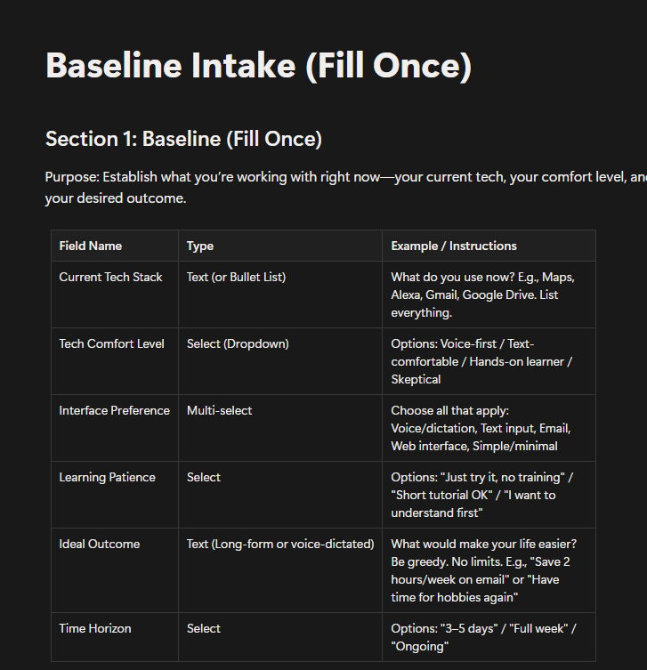

You've got this! 🌟
Technology is here to serve you — not to confuse you. Take it one step at a time,
be patient with yourself, and enjoy the extra time you get back. 💚

